**Documentation**

**Project-Tic-Tac-Toe**

**Team: The Red Pandas**

Table of Contents

Team members: 3

Educational Institution: 3

History of the game: 4

Elements of the game: 4

Rules of the game: 4

Conditions for victory: 4

Selected programming technologies: 5

Description of C++ functions: 6

Block Diagram 11

# 

# Team members:

Radoslav Lisitsov- Scrum Trainer;

Kamelia Ivanova, Maria Kostova - Developer 1 Front End;

Niya Runcheva - Developer 2 C++;

Georgi Vasilev, Kalina Noncheva - Developer 3 Code Checker;

Contacts:

[RPLisitsov19@codingburgas.bg](mailto:RPLisitsov19@codingburgas.bg);

[KIIvanova19@codingburgas.bg](mailto:KIIvanova19@codingburgas.bg);

[MDKostova19@codingburgas.bg](mailto:MDKostova19@codingburgas.bg);

[NSRuncheva19@codingburgas.bg](mailto:NSRuncheva19@codingburgas.bg);

[KPNoncheva19@codingburgas.bg](mailto:KPNoncheva19@codingburgas.bg);

[GAVasilev19@codingburgas.bg](mailto:GAVasilev19@codingburgas.bg);

# Educational Institution:

Vocational High School of Computer Programming and Innovations;

# History of the game:

Tic-Tac-Toe, also known as the game of crosses and circles, is one of the most popular, world-famous games. It is believed that it’s earliest version was played by the population of ancient Egypt, and historical records show that the outlines of it’s playing field were found carved on the walls of a number of temples throughout Rome, as well as on the walls of some medieval, English cathedrals.

From antiquity to the present day, Tic-Tac-Toe has been a game that has entertained people for centuries. And while it's more popular today as a child's play, the situation hasn't always looked that way.

How the game progressed beyond that is a bit more unclear. Some say there are records of it being played in the Middle Ages, with a mystic attachment to it, but the most concrete reappearance we have of it comes sometime later. In the 18th century in England, record of a children’s game close to Tic-Tac-Toe as we know it first appeared. While there isn’t a concrete understanding of what happened next, most likely the game was passed onto American and other international shores via England’s history of colonization and immigration.

So, with all this said, how did the name progress to Tic-Tac-Toe? Well, as it turns out, that name was originally ascribed to an entirely different game that no longer exists. This game was played by throwing a pencil at a slate covered with numbers, then assigning a score based on counting the numbers hit with the pencil. Think of it like a strange variation of darts. Historians believe the name at the time, Tit-Tat-Toe, came from the sound of the pencil hitting the board. With a slight Americanization to Tic-Tac-Toe, the name would end up living on, even if the actual game wouldn’t.

Today, Tic-Tac-Toe is played worldwide, albeit not always under the same name. When played in England, it’s generally referred to as “noughts and crosses,” the same name it had when it first appeared on the scene in the 1800s. Different regions in Ireland may switch between the names “X’s and O’s,” “Boxin’ Oxen,” and “X-e O-zees.”  In Norway, it’s called “Twiddles and Bears.” The good news is that it’s pretty much played the same way in every country, so if you find yourself in an airport, drawing up that famous board is a challenge everyone can recognize.

# Elements of the game:

Circles, Crosses, 3x3 field

# Rules of the game:

It is played by two players. In turns, the players place an element on the field.

# Conditions for victory:

The goal is to arrange three identical elements in one row, one column or diagonally. Whoever ranks first equal three elements is the winner.

# Selected programming technologies:

C ++; HTML & CSS

# Description of C++ functions:

Function name: Menu Return

value type: void

Arguments: none

What it is used for: shows the game menu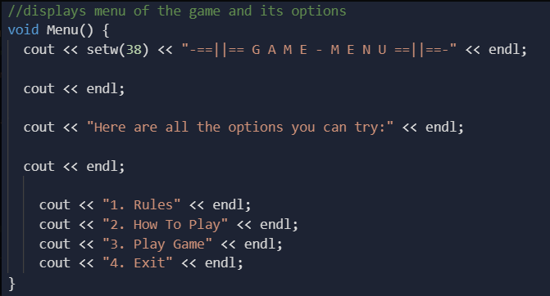

Function name: Rules

Return value type: void

Arguments: none

What it is used for: takes out a sheet with the rules of the traditional game

Function name: Continue

Return value type: void

Arguments: char, in

What it is used for: shows the game menu if the user wants to view another option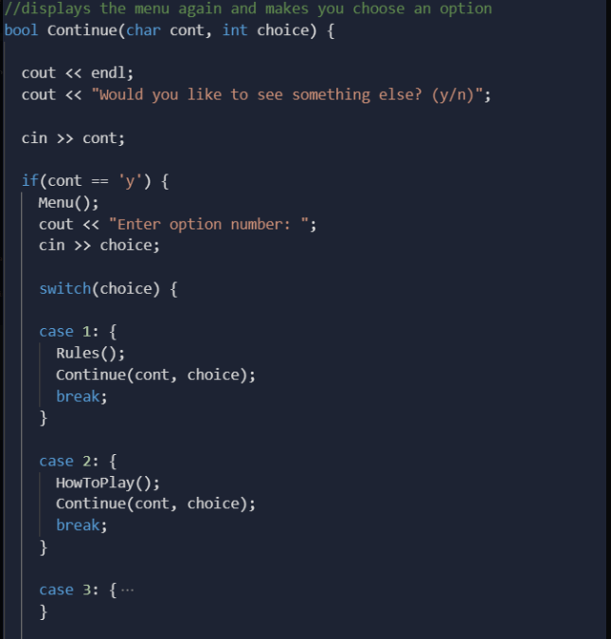

Function name: HowToPlay

Return value type: void

Arguments: none

What it is used for: gives instructions on how to play our game

Function Name: PlayGame

Return value type: void

Arguments: none

What it is used for: the game itself

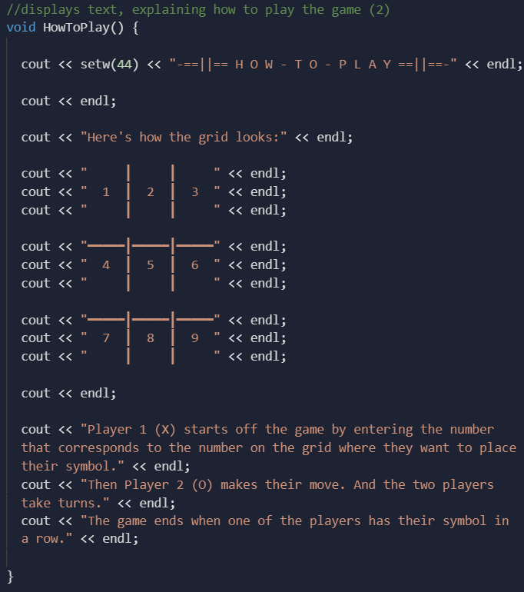

Function name: Exit Return

value type: bool

Arguments: none

What it is used for: terminates the code

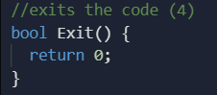

Function Name: findWinner

Return value type: int

Arguments: none

What it is used for: checks if symbols are in a row and finds the winner of the game

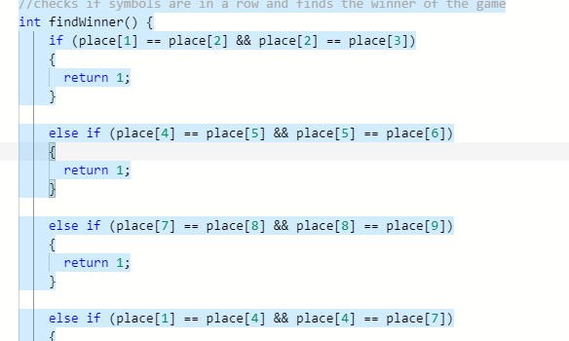

Function Name: playField

Return value type: void

Arguments: none

What it is used for: prints game board

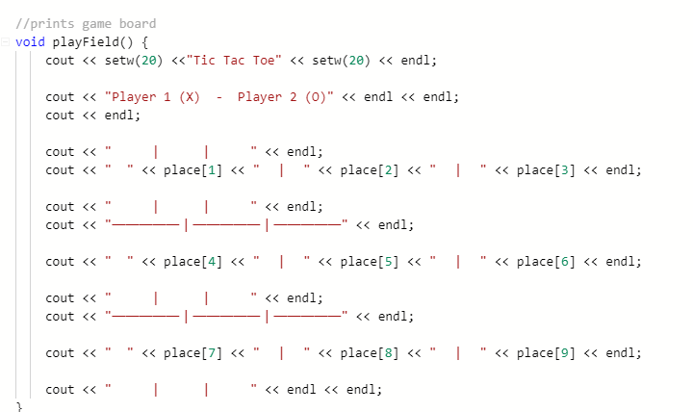

# Block Diagram:

